**National University of Science and Technology**

**Military College of Signals**

**Department of Computer Software Engineering**

**Numerical Methods Project Proposal**

**Simulation of Fluid Flow**

The primary objective of this project is to utilize numerical methods to solve the Navier-Stokes equations, which describe the motion of fluid substances. The project will focus on simulating and visualizing fluid flow in various geometries using MATLAB.

Computational Fluid Dynamics (CFD) is a crucial field of study in both academia and industry, enabling the analysis of fluid flow problems that are otherwise challenging to solve analytically. The Navier-Stokes equations form the foundation of CFD, governing the behavior of fluids in motion. Solving these equations numerically allows us to simulate complex fluid flows, making it possible to analyze engineering designs, natural phenomena, and various applications in aerodynamics, hydrodynamics, and process engineering.

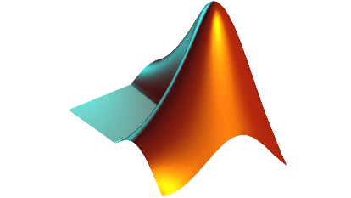 This project aims to provide a comprehensive understanding of fluid dynamics through numerical simulation. The successful completion of this project will demonstrate the power of numerical methods in solving complex fluid flow problems.

**Submitted By:**

Abdul Hannan Amir Muhammad Asim Umar Muhammad Talha

**Submitted to :**

LE. Rabia Basharat

**Section:**

BESE-28(C)